Alex Gudgel

Due: March 6th

CIS310-01

A7

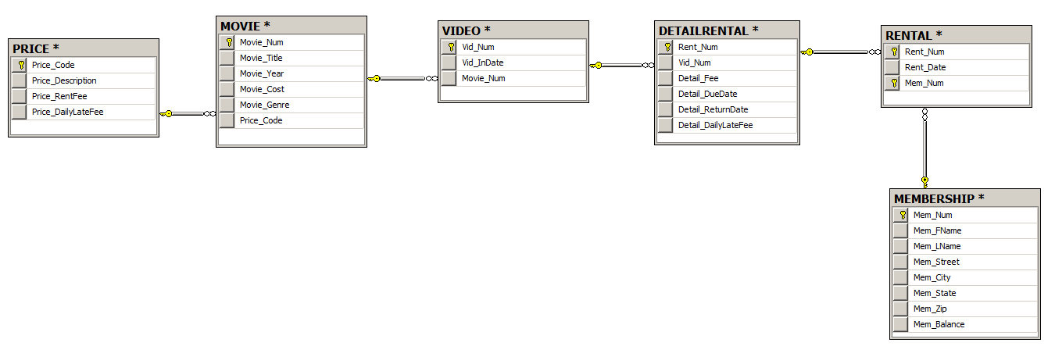

--103

SELECT MOVIE_TITLE, MOVIE_YEAR, MOVIE_GENRE

FROM MOVIE

--104

SELECT MOVIE_YEAR, MOVIE_TITLE, MOVIE_COST

FROM MOVIE

ORDER BY MOVIE_YEAR DESC

--105

SELECT MOVIE_TITLE, MOVIE_YEAR, MOVIE_GENRE

FROM MOVIE

ORDER BY MOVIE_GENRE, MOVIE_YEAR DESC

--106

SELECT MOVIE_NUM, MOVIE_TITLE, PRICE_CODE

FROM MOVIE

WHERE MOVIE_TITLE LIKE 'R%'

--107

SELECT MOVIE_TITLE, MOVIE_YEAR, MOVIE_COST

FROM MOVIE

WHERE MOVIE_TITLE LIKE '%hope%'

ORDER BY MOVIE_TITLE

--108

SELECT MOVIE_TITLE, MOVIE_YEAR, MOVIE_GENRE

FROM MOVIE

WHERE MOVIE_GENRE = 'ACTION'

--109

SELECT MOVIE_NUM, MOVIE_TITLE, MOVIE_COST

FROM MOVIE

WHERE MOVIE_COST > 40

--110

SELECT MOVIE_NUM, MOVIE_TITLE, MOVIE_COST, MOVIE_GENRE

FROM MOVIE

WHERE MOVIE_GENRE IN ('ACTION', 'COMEDY')

AND MOVIE_COST < 50

ORDER BY MOVIE_GENRE

--111

SELECT MEM_NUM, MEM_FNAME, MEM_LNAME, MEM_STREET, MEM_STATE, MEM_BALANCE

FROM MEMBERSHIP

WHERE MEM_STATE = 'TN' AND MEM_BALANCE < 5

AND MEM_STREET LIKE '%Avenue'

--112

SELECT MOVIE_GENRE, COUNT (MOVIE_GENRE) AS "NUMBER OF MOVIES"

FROM MOVIE

GROUP BY MOVIE_GENRE

--113

SELECT AVG(MOVIE_COST) AS "AVERAGE MOVIE COST"

FROM MOVIE

--114

SELECT MOVIE_GENRE, AVG(MOVIE_COST) AS "AVERAGE COST"

FROM MOVIE

GROUP BY MOVIE_GENRE

--115

SELECT A.MOVIE_TITLE, A.MOVIE_GENRE, B.PRICE_DESCRIPTION, B.PRICE_RENTFEE

FROM MOVIE A, PRICE B

WHERE A.PRICE_CODE = B.PRICE_CODE

--116

SELECT A.MOVIE_GENRE, AVG(PRICE_RENTFEE) AS "AVERAGE RENTAL FEE"

FROM MOVIE A, PRICE B

WHERE A.PRICE_CODE = B.PRICE_CODE

GROUP BY MOVIE_GENRE

--117

SELECT A.MOVIE_TITLE, MOVIE_COST/PRICE_RENTFEE AS "BREAKEVEN RENTALS"

FROM MOVIE A, PRICE B

WHERE A.PRICE_CODE = B.PRICE_CODE

--118

SELECT MOVIE_TITLE, MOVIE_YEAR

FROM MOVIE

WHERE PRICE_CODE is not null

--119

SELECT MOVIE_TITLE, MOVIE_GENRE, MOVIE_COST

FROM MOVIE

WHERE MOVIE_COST >= 44.99 AND MOVIE_COST <= 49.99

--120

SELECT M.MOVIE_TITLE, P.PRICE_DESCRIPTION, P.PRICE_RENTFEE, M.MOVIE_GENRE

FROM MOVIE M, PRICE P

WHERE MOVIE_GENRE IN ('FAMILY', 'COMEDY', 'DRAMA')

AND M.PRICE_CODE = P.PRICE_CODE

--121

SELECT DISTINCT M.MEM_NUM, M.MEM_FNAME, M.MEM_LNAME, M.MEM_BALANCE

FROM MEMBERSHIP M,RENTAL R

WHERE M.MEM_NUM = R.MEM_NUM

--122

SELECT MIN(MEM_BALANCE) AS "MINIMUN BALANCE", MAX(MEM_BALANCE) AS "MAXIMUM BALANCE",

AVG(MEM_BALANCE) AS "AVERAGE BALANCE"

FROM MEMBERSHIP

WHERE MEM_NUM IN (SELECT MEM_NUM FROM RENTAL)

--123

SELECT R.RENT_NUM, R.RENT_DATE, V.VID_NUM, M.MOVIE_TITLE, D.DETAIL_DUEDATE, D.DETAIL_RETURNDATE

FROM RENTAL R INNER JOIN DETAILRENTAL D ON R.RENT_NUM = D.RENT_NUM

INNER JOIN VIDEO V ON D.VID_NUM = V.VID_NUM

INNER JOIN MOVIE M ON V.MOVIE_NUM = M.MOVIE_NUM

WHERE DETAIL_RETURNDATE > DETAIL_DUEDATE

ORDER BY R.RENT_NUM, MOVIE_TITLE

--124

SELECT R.RENT_NUM, R.RENT_DATE, M.MOVIE_TITLE, D.DETAIL_FEE

FROM RENTAL R INNER JOIN DETAILRENTAL D ON R.RENT_NUM = D.RENT_NUM

INNER JOIN VIDEO V ON D.VID_NUM = V.VID_NUM

INNER JOIN MOVIE M ON V.MOVIE_NUM = M.MOVIE_NUM

WHERE D.DETAIL_RETURNDATE <= D.DETAIL_DUEDATE

--125

SELECT MOVIE_NUM, MOVIE_GENRE, AVG (MOVIE_COST) AS "AVERAGE COST", MOVIE_COST,

((MOVIE_COST - AVG(MOVIE_COST))/(AVG (MOVIE_COST)))*100 AS "PERCENT DIFFERENCE"

FROM MOVIE

GROUP BY MOVIE_NUM, MOVIE_GENRE, MOVIE_COST